***LCM of Two Numbers***

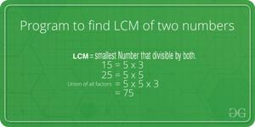

LCM (Least Common Multiple) of two numbers is the smallest number which can be divided by both numbers.

For example, LCM of 15 and 20 is 60, and LCM of 5 and 7 is 35.

A **simple solution** is to find all prime factors of both numbers, then find union of all factors present in both numbers. Finally, return the product of elements in union.

An **efficient solution**is based on the below formula for LCM of two numbers ‘a’ and ‘b’.

a x b = LCM(a, b) * GCD (a, b)

LCM(a, b) = (a x b) / GCD(a, b)

We have discussed function to find GCD of two numbers. Using GCD, we can find LCM.

Below is the implementation of the above idea:

C++Java

// Java program to find LCM of two numbers.

class Test

{

// Recursive method to return gcd of a and b

static int gcd(int a, int b)

{

if (a == 0)

return b;

return gcd(b % a, a);

}

// method to return LCM of two numbers

static int lcm(int a, int b)

{

return (a / gcd(a, b)) * b;

}

// Driver method

public static void main(String[] args)

{

int a = 15, b = 20;

System.out.println("LCM of " + a +

" and " + b +

" is " + lcm(a, b));

}

}

**Output**

LCM of 15 and 20 is 60

***Time Complexity:****O(log(min(a,b))*

***Auxiliary Space:****O(log(min(a,b))*